Buxton & Leek October 2021

Hello Autumn We are delighted to announce our learner commercial led student sessions are now live and available to book for the hairdressing at Buxton and Leek College.
To begin with these are limited to certain days but more sessions will become available as the months progress
We currently have 20% off our entire retail range for you to peruse from leading industry brands Dermalogica, MAC, Graftons and Wella.
Looking for that perfect gift? Why not give the gift of time with our ever-popular vouchers starting from just £15

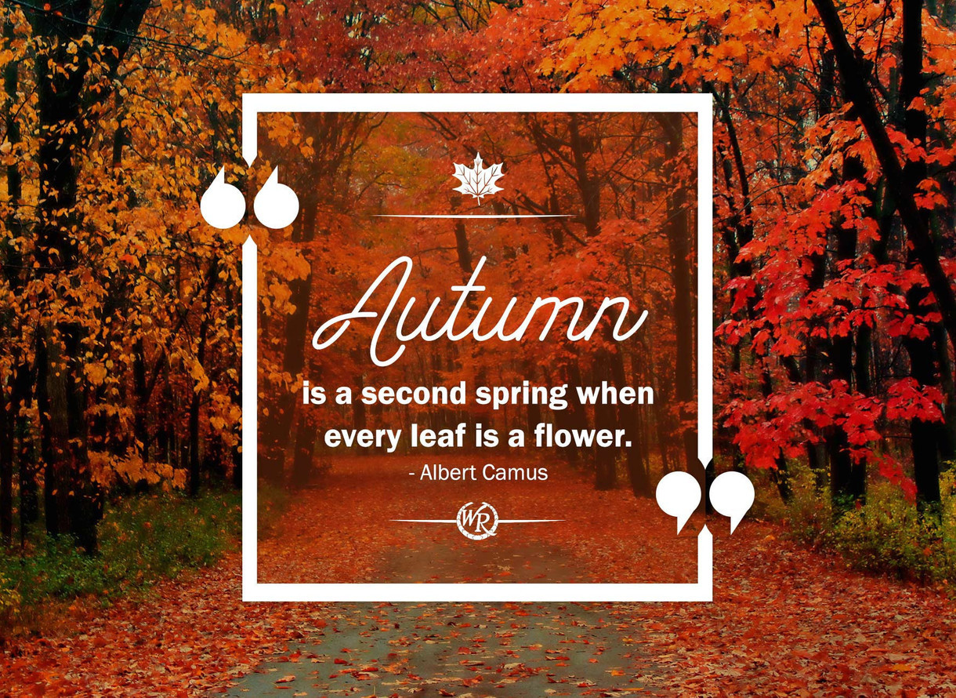

Did You Know!If you are a student or member of staff you automatically receive 20% discount on all of our hair and beauty treatments & services too!
We value our clients past, present and those we have yet to meet! And to welcome you back we have a fantastic offer.
October Offer Luxury Deep Conditioning/Scalp Treatment & Straighten just £5.
To keep up to date with all our special offers please follow us on The Salon at Buxton and Leek – we would really appreciate a like and a share or WWW.DEVONSHIREDOME.CO.UK and click on our Salon page

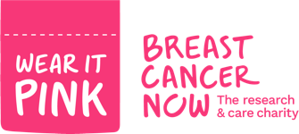

Wear Pink For October In aid of breast cancer awareness for the entire week Mon 18th Oct-22nd October all our hair & beauty students are encouraged to swop their uniform tunic for the brightest boldest pink top they own. Think about customising or pimping up your pullover. You will be asked kindly to donate £1 to the cause. There will be a prize for the best jumper. There will be fun and games on the day including refreshments and a raffle. A percentage of client payments for the week will also be donated to the cause.
Around 55,000 women and 370 men are diagnosed with breast cancer every year in the UK. In England, every year around 46,000 people are diagnosed with breast cancer. In Scotland, every year around 4,700 people are diagnosed with breast cancer. In Wales, every year around 2,800 people are diagnosed with breast cancer. Cancer affects the lives of 1 in every 2 people so it’s vital that we get on board and support the amazing research work being carried out, early detection and preventative treatment is vital.
Advanced Notification Special November Offer
Manicure & Pedicure Package just £10 Buxton Salon ONLY (selected sessions)

To keep up to date with all our special offers please follow us on The Salon at Buxton and Leek – we would really appreciate a like and a share or visit WWW.DEVONSHIREDOME.CO.UK/Salon page. Alternatively you can email any enquiries to HairAndBeauty@derby.ac.uk

Did somebody say the C word? 12 weeks until Christmas! Look out for our early promotions arriving soon…

